HADOOP- Big Data Project Titles

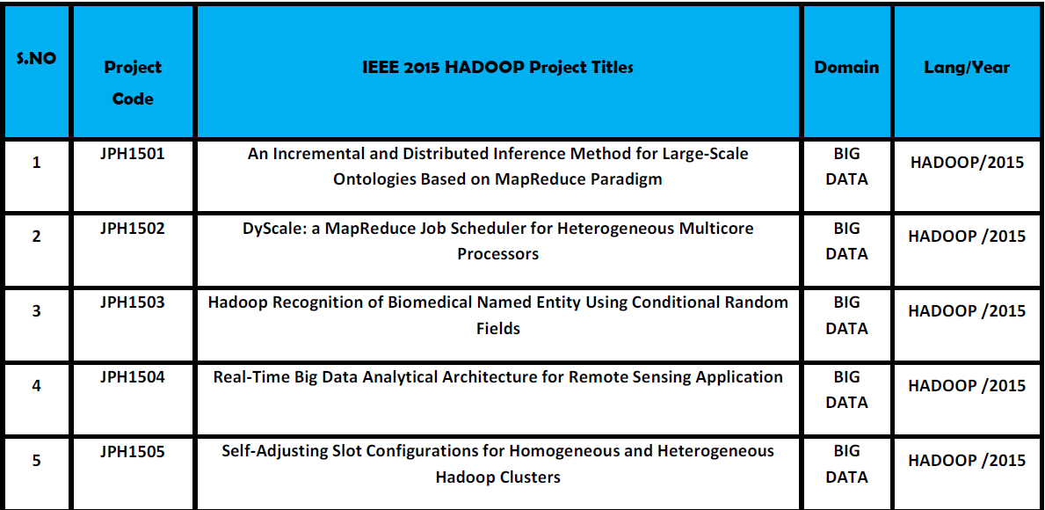
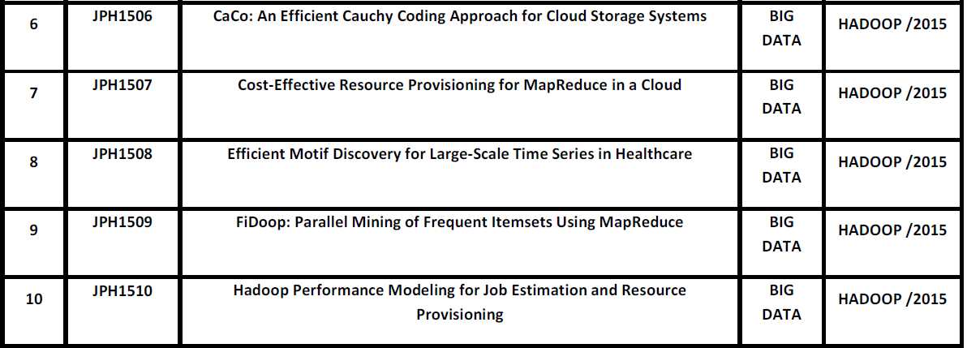
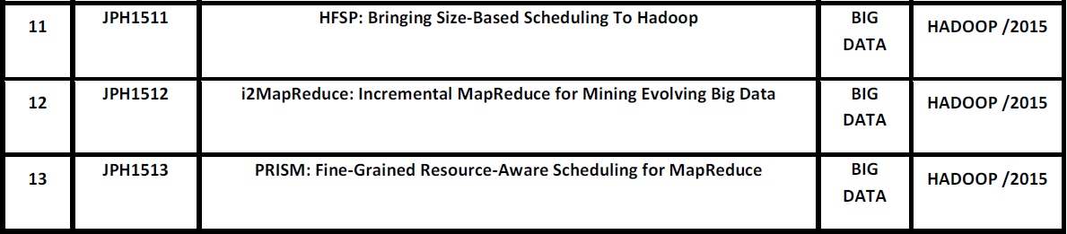
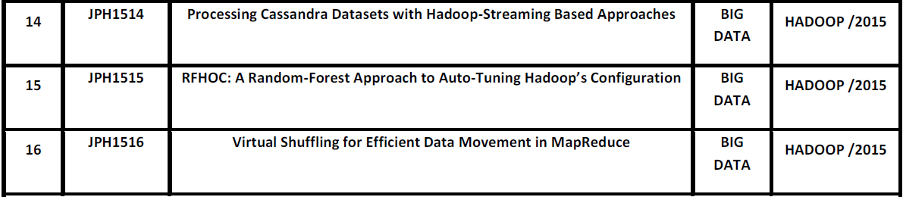

- On Traffic-Aware Partition and Aggregation in Map Reduce for Big Data Applications(2015)

- Fast RAQ: A Fast Approach to Range-Aggregate Queries in Big Data Environments(2015)

- Privacy-Preserving Cipher text Sharing Mechanism for Big Data Storage(2015)

- Cost Minimization for Big Data Processing inGeo-Distributed Data Centers(2014)

- ClubCF A Clustering-based Collaborative Filtering Approach for Big Data Application(2014)

- Data Mining with Big Data(2014)

- KASR: A Keyword-Aware Service Recommendation Method on MapReduce for Big Data Applications (2014)

- DynamicMR: A Dynamic Slot Allocation Optimization Framework for MapReduce Clusters (2014)

- Extending MapReduce across Clouds with Bstream (2014)

- Budget-Driven Scheduling Algorithms for Batches of MapReduce Jobs in Heterogeneous Clouds (2014)

- A Scalable Two-Phase Top-Down Specialization Approach for Data Anonymization Using MapReduce On Cloud (2014)

- Dache: A Data Aware Caching for Big-Data Applications Using the MapReduce Framework (2014)

